**Southern University of Science and Technology**

**Computer Networking Lab Report**

**唐润哲 11710418**

* ***Introduction：***

***#Problem7.1***

Select one UDP packet from your trace. From this packet, determine

* 1. how many fields there are in the UDP header.
  2. the name of each fields in the UDP header.
  3. the length (in bytes) of each fields in the UDP header.
  4. What is the maximum number of bytes that can be included in a UDP payload?(Hint: the answer to this question can be determined by your answer to 3) above)
  5. What is the largest possible source port number? (Hint: same as the hint in 4) above.)
  6. What is the protocol number for UDP?( Give your answer in both hexadecimal and decimal notation. )

***# Problem 7.2***

* 4.What is the sequence number of the TCP SYN segment that is used to initiate the TCP connection between the client computer and gaia.cs.umass.edu? What is it in the segment that identifies the segment as a SYN segment?
* 6. What is the sequence number of the TCP segment containing the HTTP POST command? Note that in order to find the POST command, you’ll need to dig into the packet content field at the bottom of the Wireshark window, looking for a segment with a “POST” within its DATA field.
* 7. Consider the TCP segment containing the HTTP POST as the first segment in the TCP connection. What are the sequence numbers of the first six segments in the TCP connection (including the segment containing the HTTP POST)? At what time was each segment sent? When was the ACK for each segment received? Given the difference between when each TCP segment was sent, and when its acknowledgement was received, what is the RTT value for each of the six segments? What is the EstimatedRTT value (see Section 3.5.3, page 242 in text) after the receipt of each ACK? Assume that the value of the EstimatedRTT is equal to the measured RTT for the first segment, and then is computed using the Estimated RTT equation on page 242 for all subsequent segments.
* 9. What is the minimum amount of available buffer space advertised at the received for the entire trace? Does the lack of receiver buffer space ever throttle the sender?
* 10. Are there any retransmitted segments in the trace file? What did you check for (in the trace) in order to answer this question?
* 12. What is the throughput (bytes transferred per unit time) for the TCP connection? Explain how you calculated this value.
* ***Result：***

***# Problem 7.1***



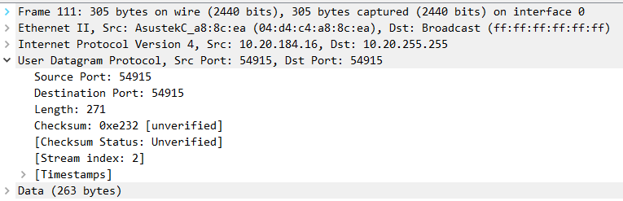

Figure.1

According to the Figure.1 captured above:

1. 4 fields in the UDP header
2. Source Port; Destination Port; Length; Checksum
3. 2 bytes for each filed
4. field: length = 2 bytes, and the UDP header has 8 bytes,

so maximum number of bytes =216-1-8=65527 bytes

1. field: source port = 2 bytes,

so maximum source port number = 216-1=65535

1. protocol number for UDP=0x11 in hexadecimal= 17 in decimal

***# Problem 7.2***

***Q4：***

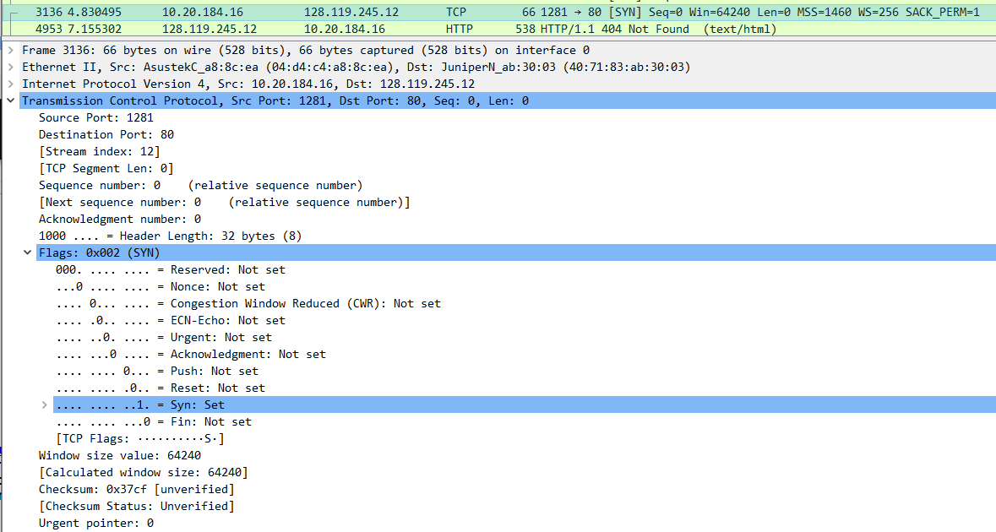

Sequence number of the TCP SYN segment: 0.

SYN flag = 1 identifies the segment as a SYN segment

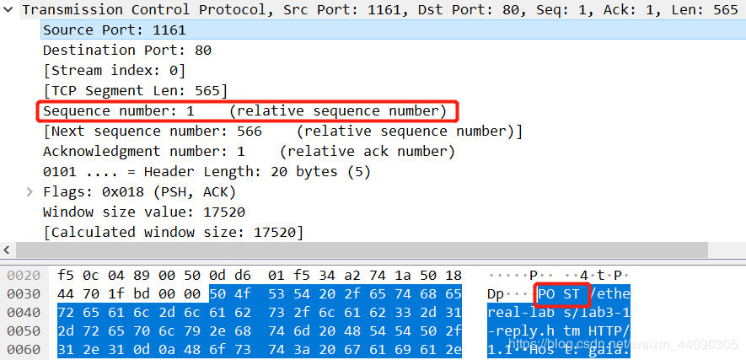***Q6：***

Sequence number of the TCP segment containing HTTP POST command: 1

***Q7：***

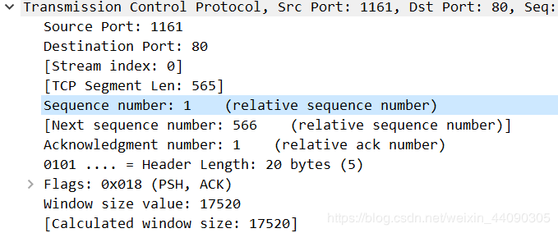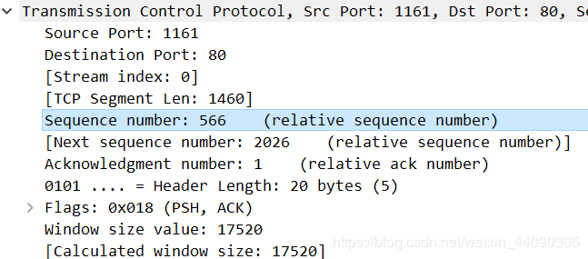

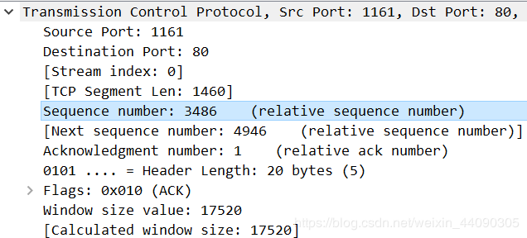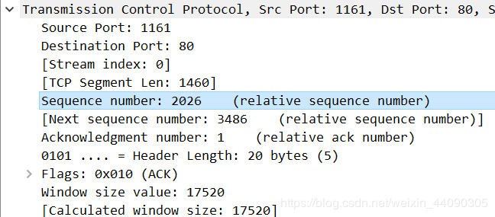

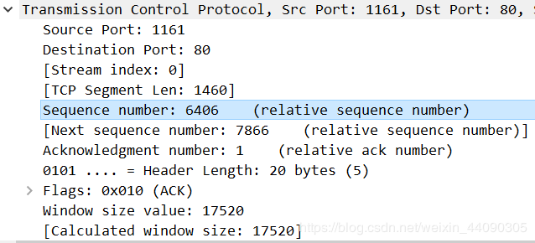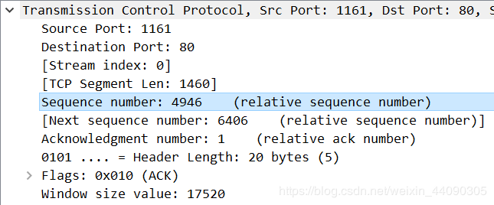

EstimatedRTT= 7/8 LastEstimatedRTT+ 1/8 SampleRTT

|  |  |  |  |  |
| --- | --- | --- | --- | --- |
| Num | Sequence Number | Sent time(s) | Ack time(s) | RTT(s) |
| 1 | 1 | 0.026477 | 0.053937 | 0.02746 |
| 2 | 566 | 0.041737 | 0.077294 | 0.02847 |
| 3 | 2026 | 0.054026 | 0.124085 | 0.03367 |
| 4 | 3486 | 0.054690 | 0.169118 | 0.04377 |
| 5 | 4946 | 0.077405 | 0.217299 | 0.05578 |
| 6 | 6406 | 0.078157 | 0.267802 | 0.07251 |

***Q9：***

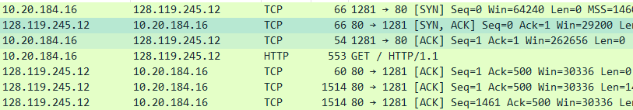

The minimum amount of available buffer space advertised is 29200. No throttle is made due to the lack of buffer space.

***Q10：***

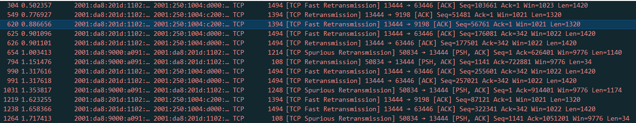

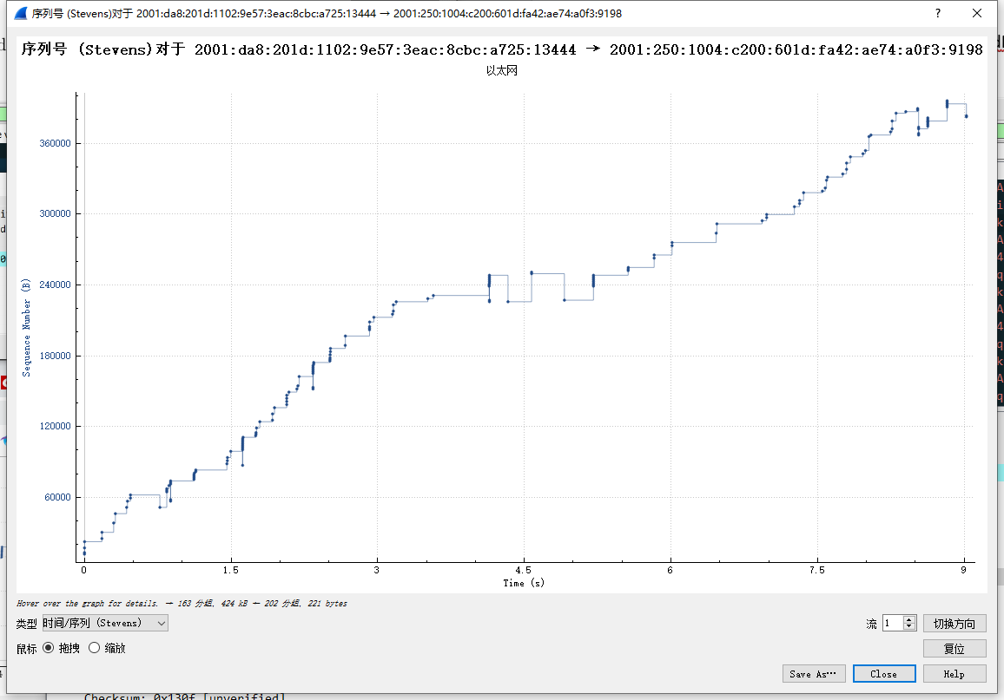

There are many retransmitted segment in the trace file. I use filter” tcp.analysis.retransmission” and specific analysis tool to make a table . If the filter shows nothing and all sequence numbers are in ascending order, it indicates that there is no retransmitted segment, which is opposite to the truth.

***Q12：***

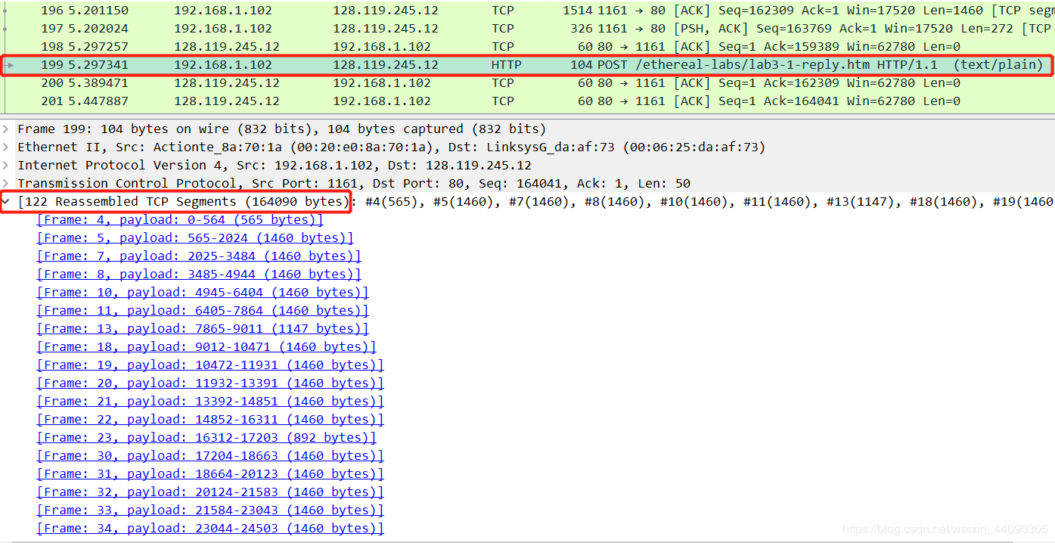

File_size = 164090bytes

Download_time = 8.987656s-5.197529s=3.790127s

throughput = file_size/download_time=43294.06376bytes/s